

# Walchand College of Engineering, Sangli

***(Government Aided Autonomous Institute)***

Department of Information Technology

Computer Networks Lab

EVEN SEMESTER AY 2021-22

*Submitted by*

Name: Om Gharge

PRN: 2020BTEIT00041

Batch: S2

Course Code: 5IT272 Date: 25/03/2022

Contact Number: 9730369761

**Department of Information Technology**

2021-22

**Experiment Number:** 8

**Experiment Name:** Configure Wi-Fi router in CISCO packet tracer using DHCP and Wireless Encryption Protocol

(WEP) in the local network.

# Contents:

**Problem Statement :** Configure Wi-Fi router in CISCO packet tracer using DHCP and Wireless Encryption Protocol

(WEP) in the local network.

**Platform :** CISCO packet tracer

**Devices Required :** PC , Switch (2960-24TT), Router (1941) and Wireless Router (WRT 300N)

**Design :**

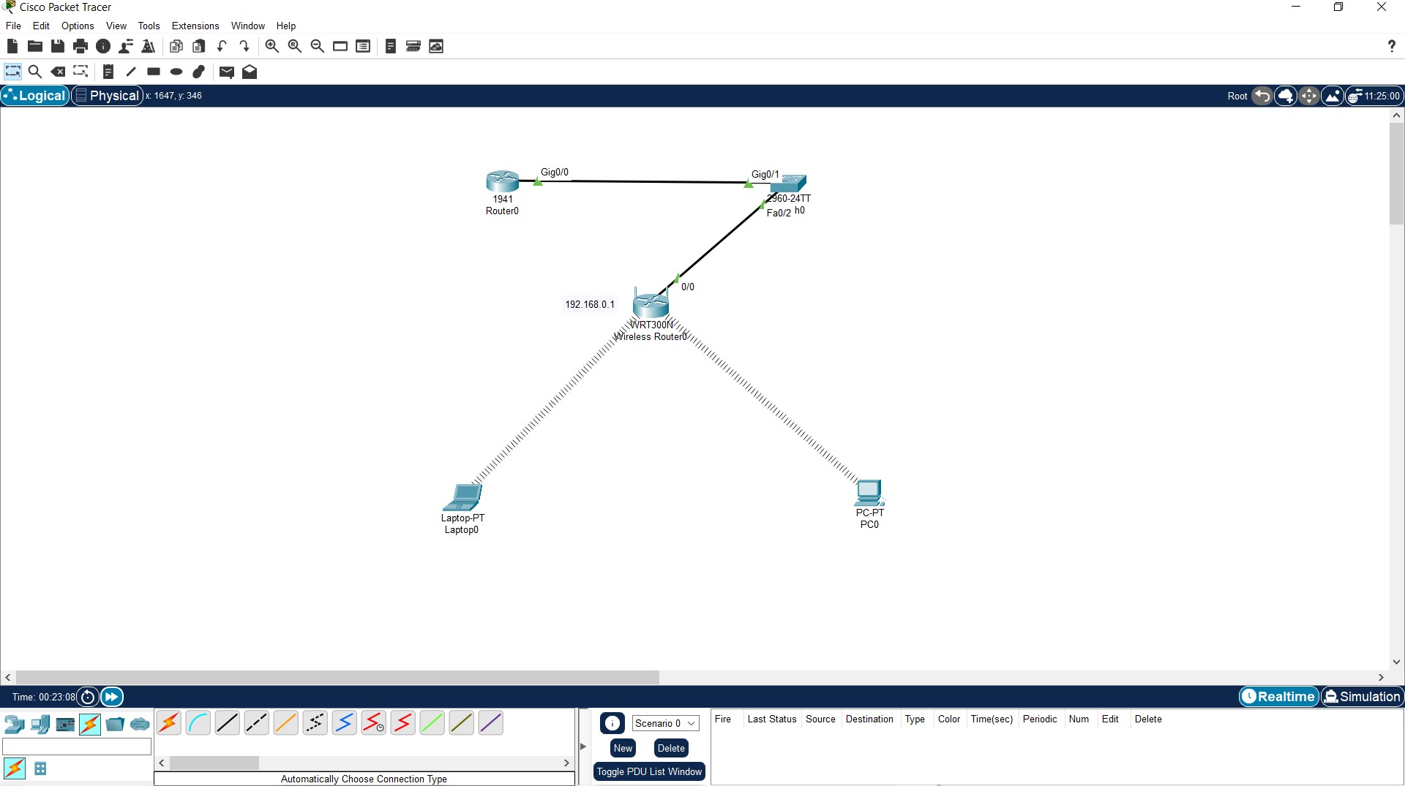

**Implementation :**

1. Create the topology as shown in the above image.
2. After creating the topology add WPC300N to the laptop and WMP300N to the computer

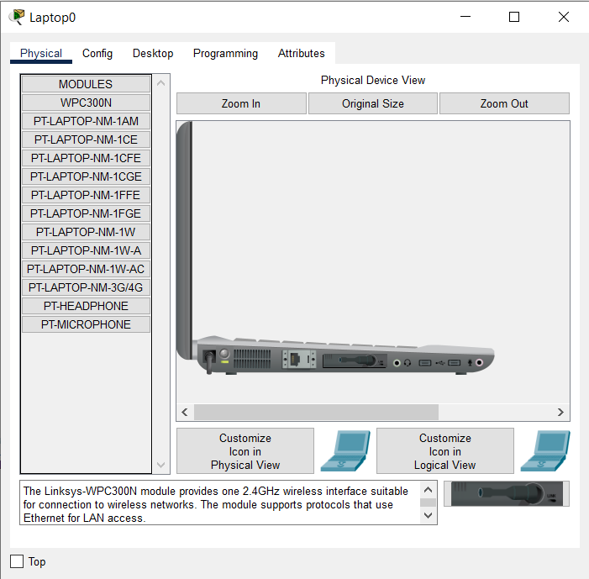 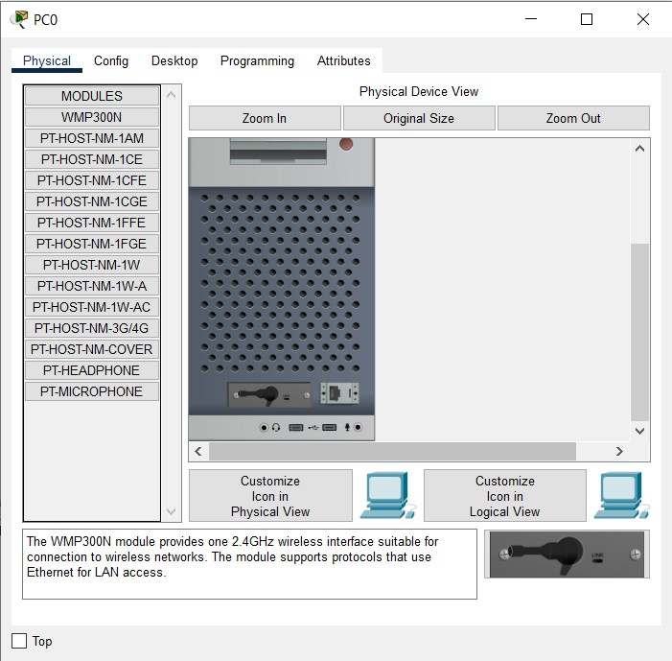

1. Dynamically give the IP addresses to the end devices using DHCP.

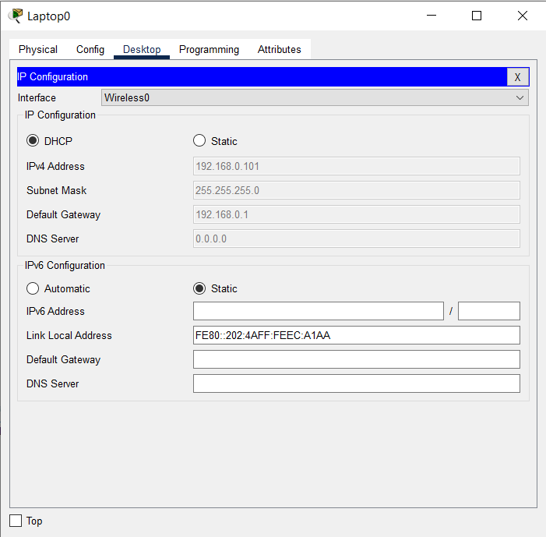

1. Connect with the wifi using the web browser of the end devices and give SSID to the wifi.

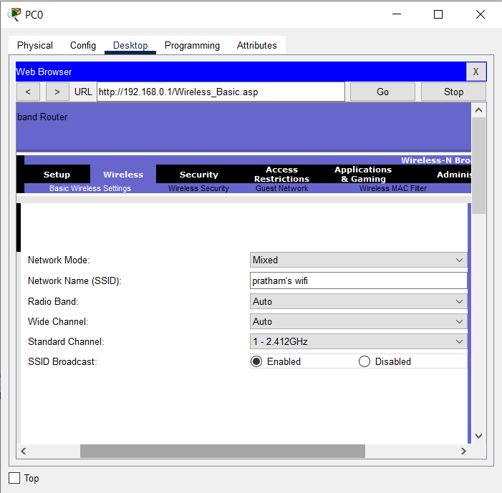

1. Enter into the wifi and give the security key to it.

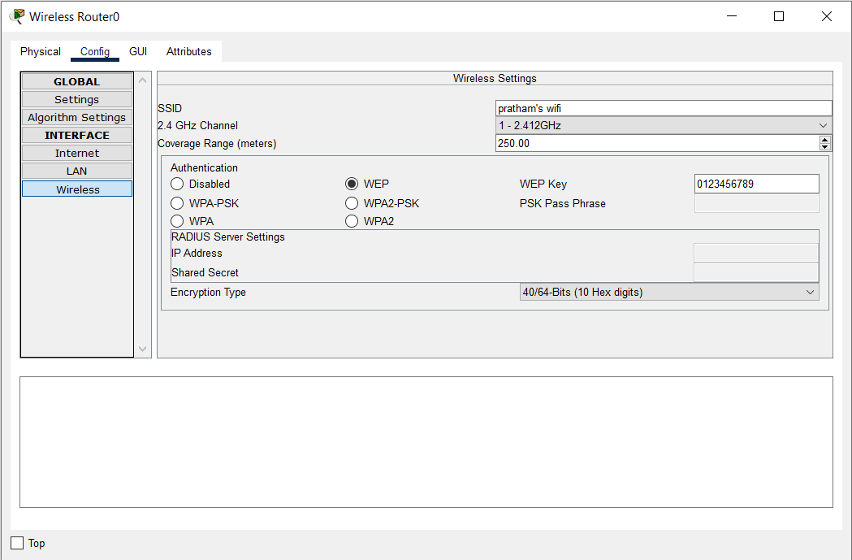

1. Connect the end devices with wifi by entering the key.

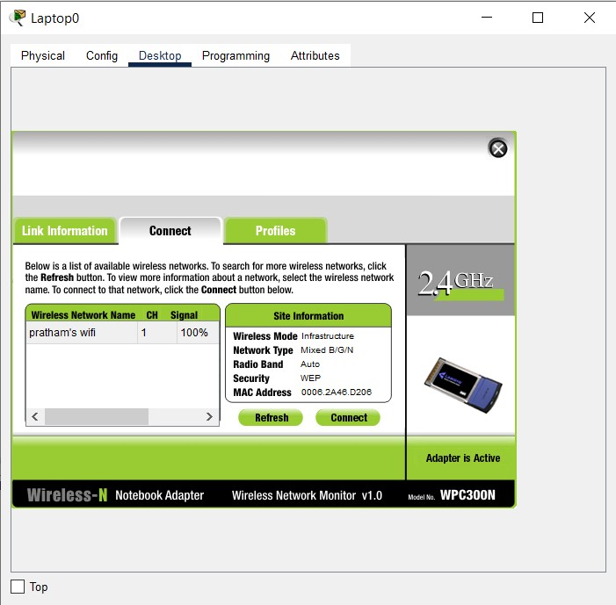

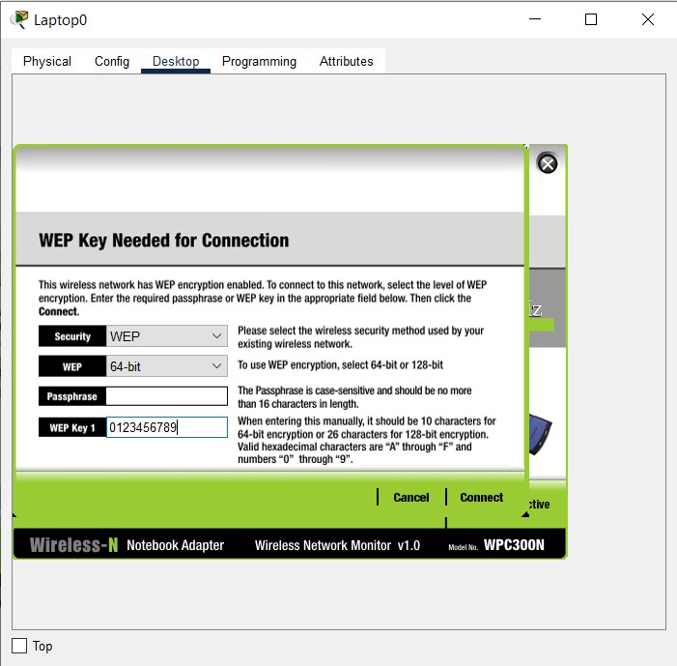

**Results:** Wifi router uses wireless medium to transmit data, end users must have wifi modules in them to connect with the wifi.

